Dev Log draft
Day 1
- Set up workspace
- Created a base for the home page
- Created a base for the about page
- Implemented bootstrap

Day 2
- Further worked on the home page
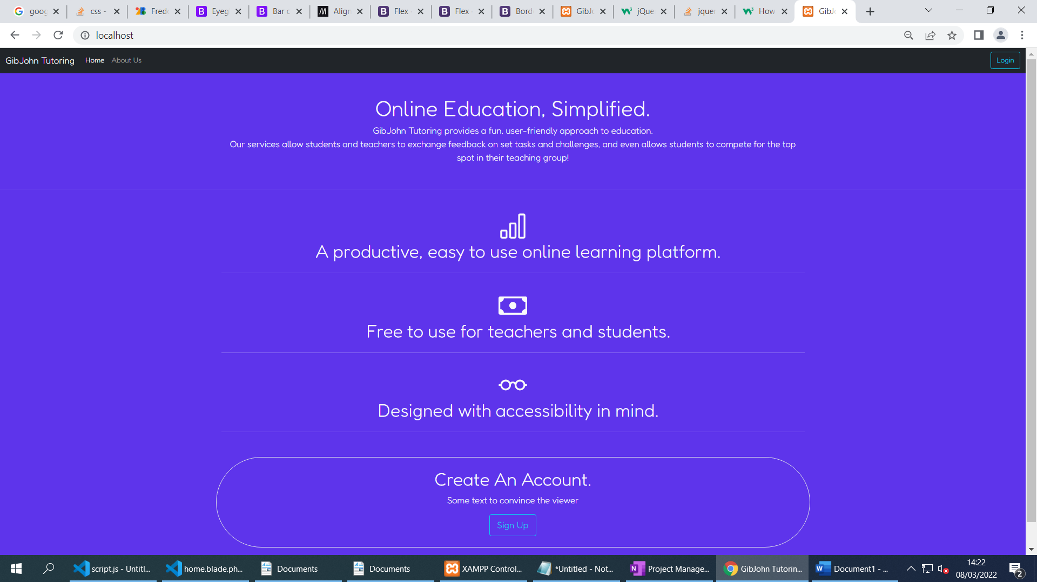
- Although the main content of the page will not be using AJAX to save time for more important features, I have added a smooth page transition using jQuery to fade between pages.
- Changed to a different font
- Implemented flex containers to make the page usable on different device types
- Created a basic To-Do list in OneNote, will work on more tomorrow.

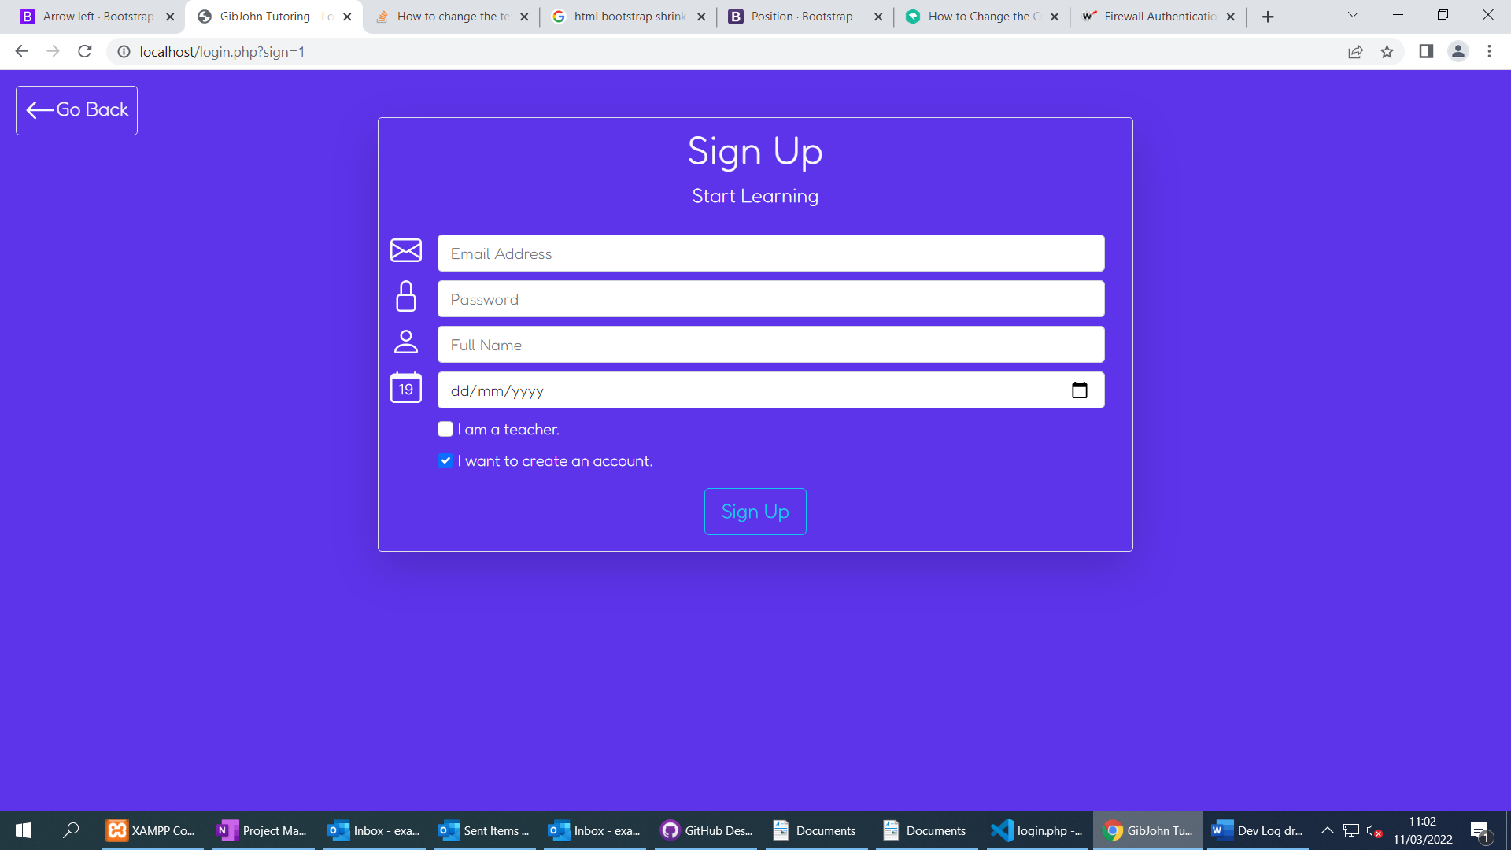
- Finished the sign up and login UI
- Made the layout dynamic using jQuery
- Created a Go Back button for better user experience
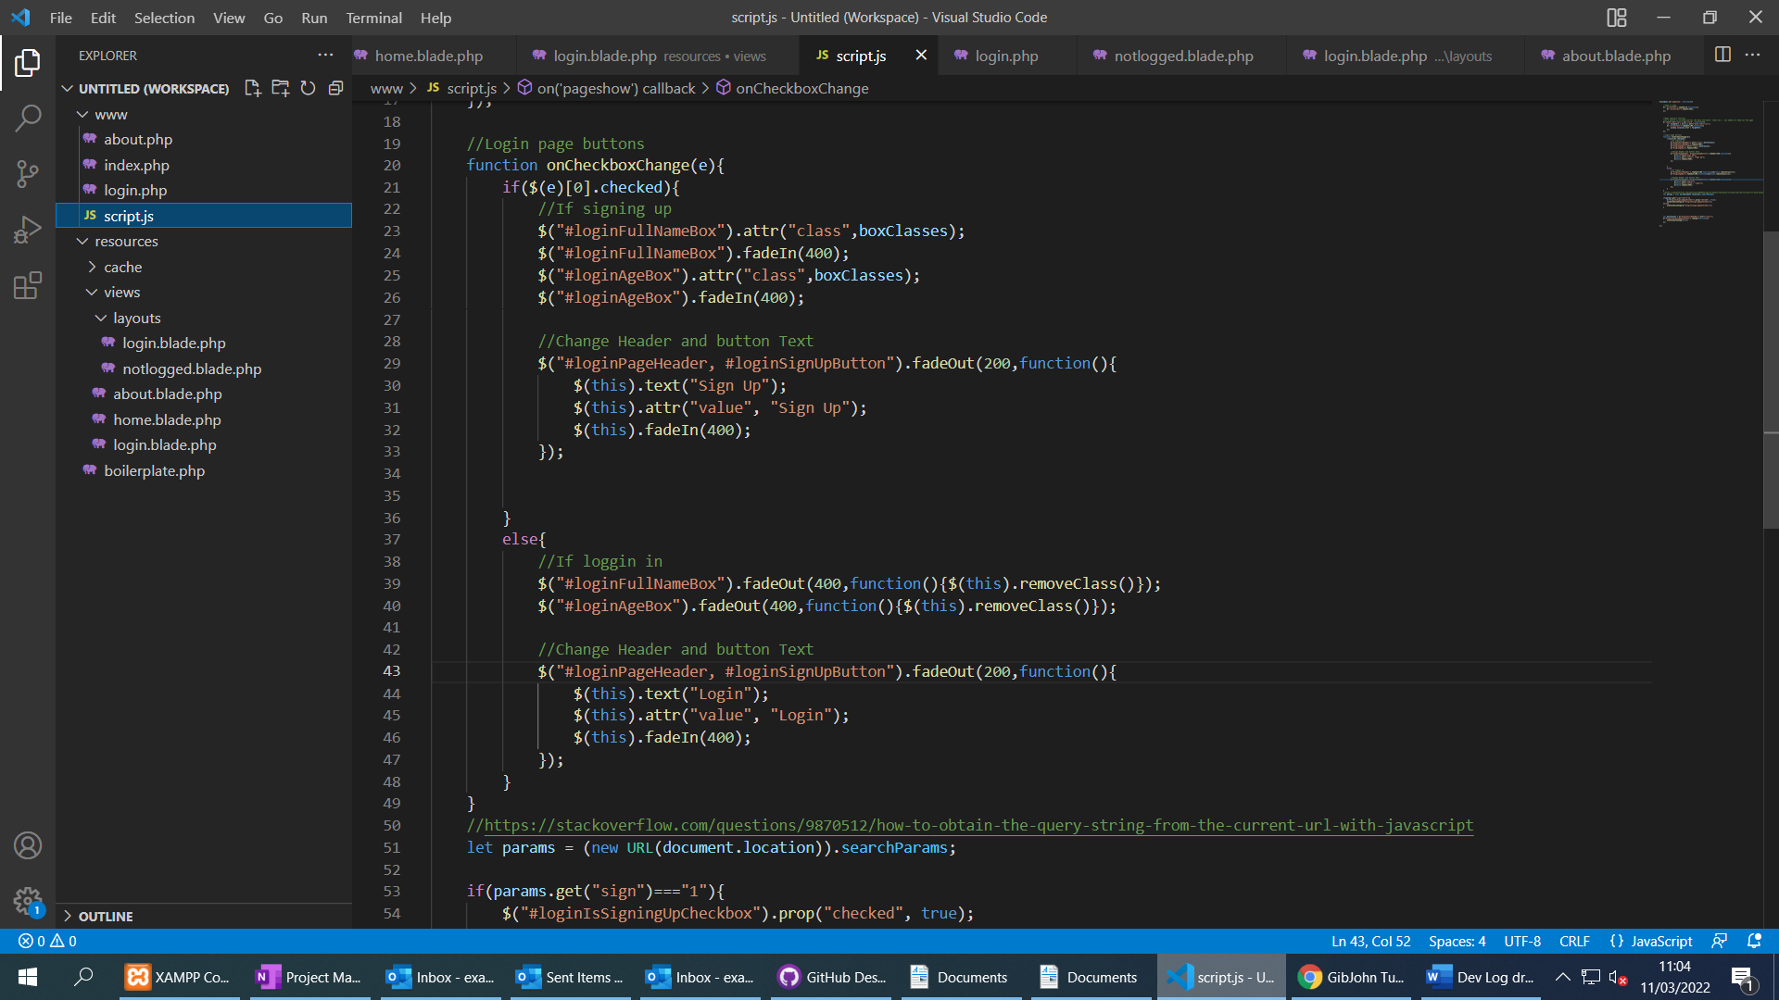

Day 3
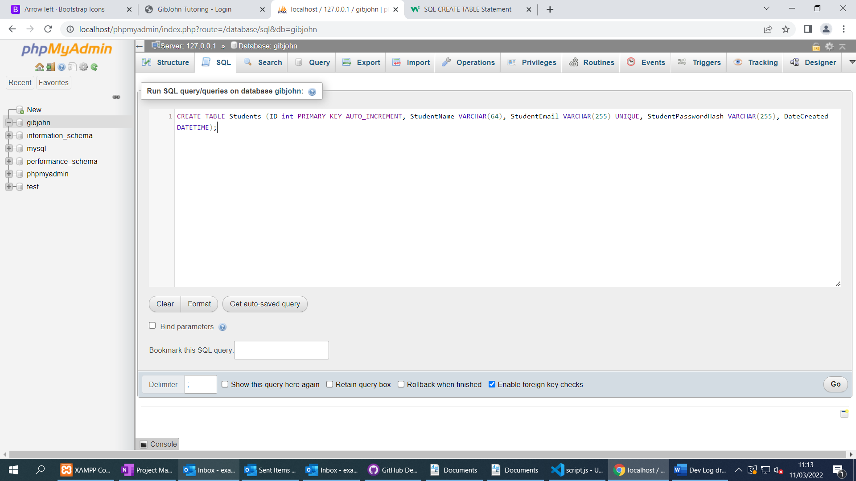
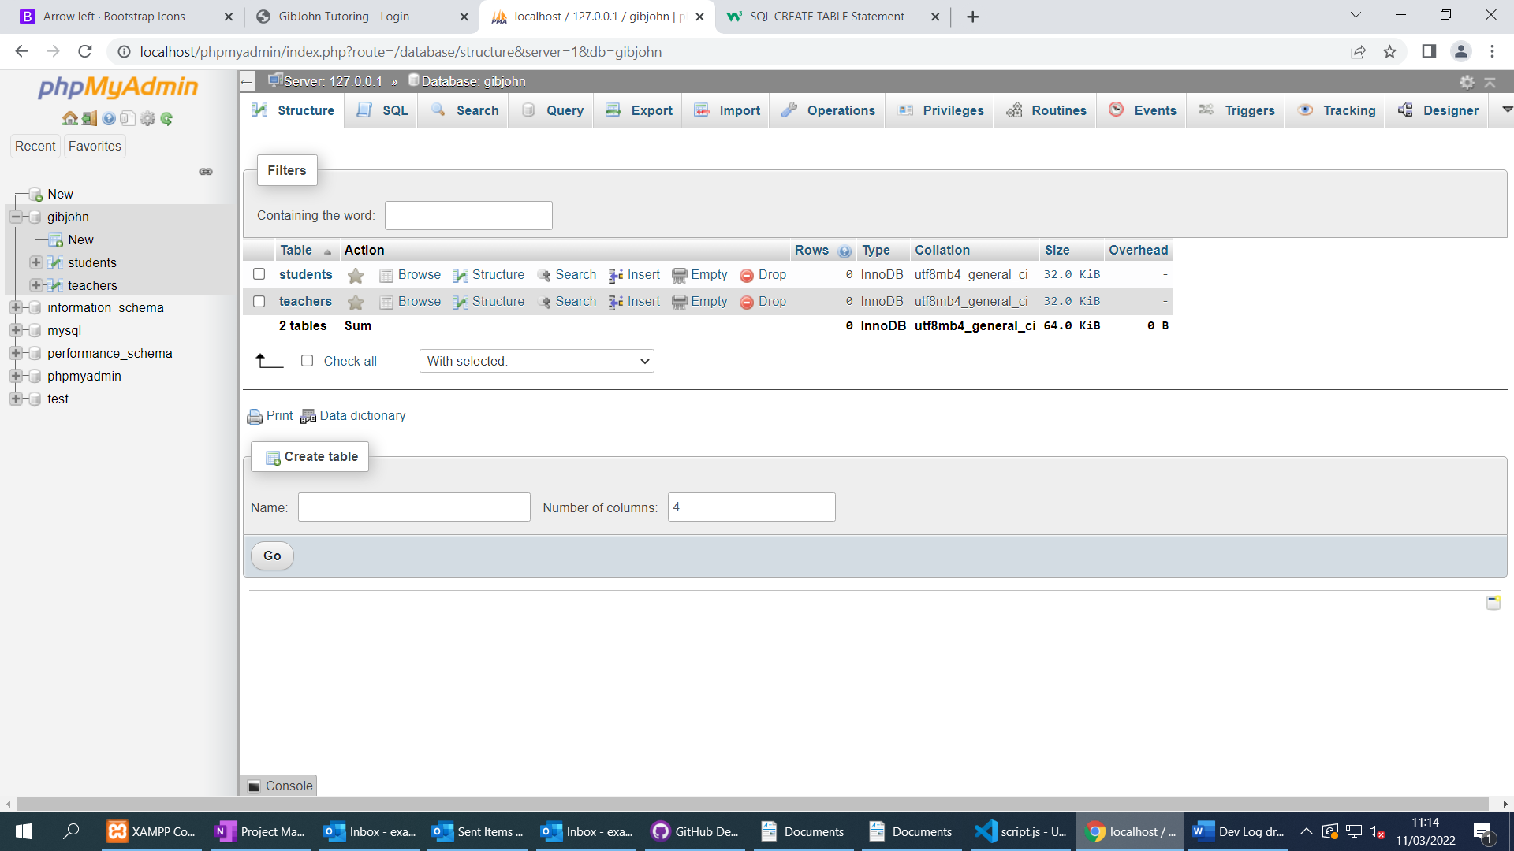
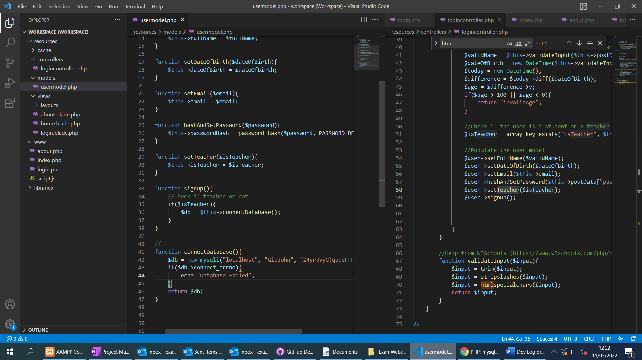

- Started working on the login system for students and teachers using Model View Controller.
- Created a database with a Students and Teachers table
- Login page sends POST data to PHP script
- Script calls Login Controller
- Login controller validates inputs and handles the login or sign-up procedure using the User Model
- Made sure code is well commented

Day 4
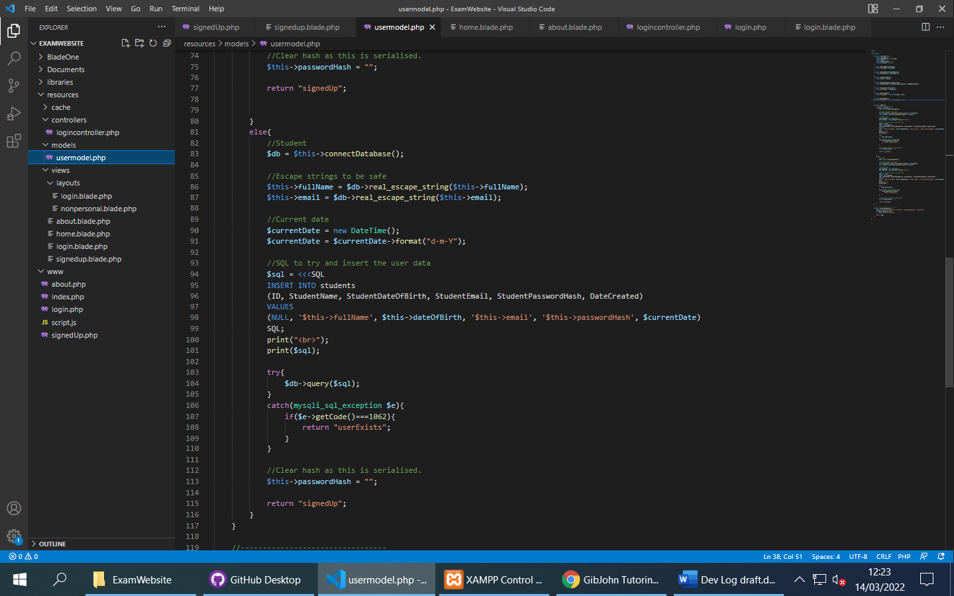
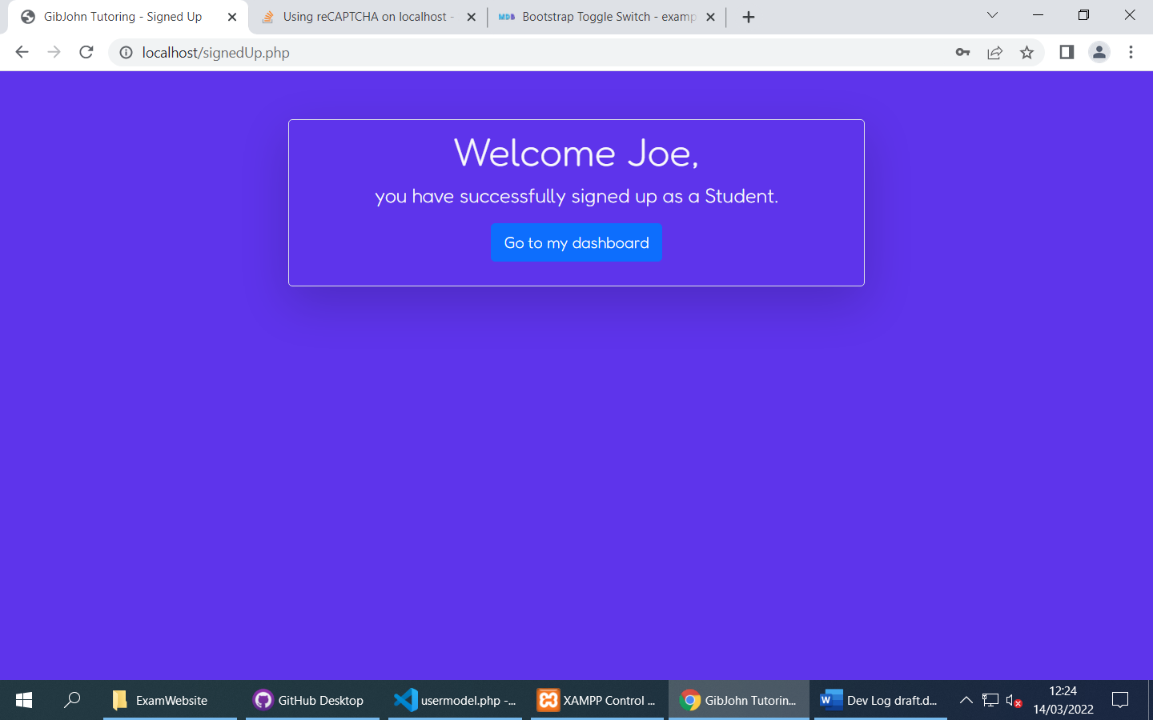
- Sign-up is now functional
- User model gets serialised and stored in the session (Sensitive data is removed)
- Some validation for age and duplicate users (and input sanitation)
- Will work on login next and then begin creating a personalised layout and dashboard.

Day 4
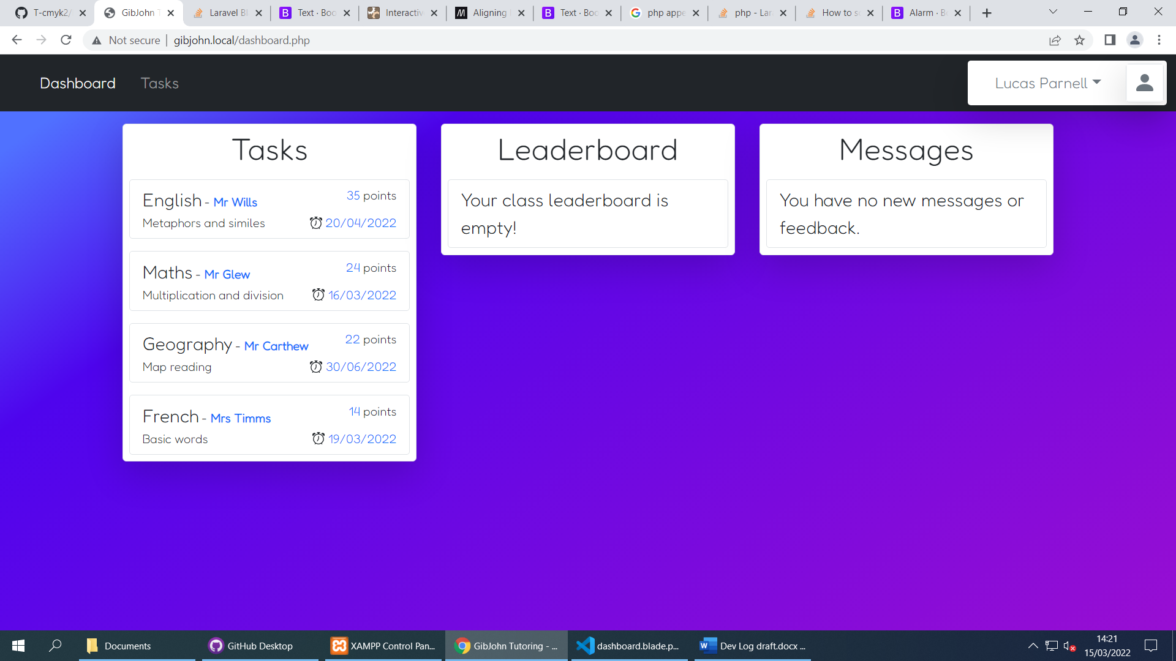
- Login system is mostly finished, just need to add client-side validation
- Worked on the personalised student dashboard, Templates can be used to easily add Tasks to the interface.
- Started working on a profile drop down interface that displays some information about the user as well as a log out button
- Next, I need to figure out flexbox wrapping as currently the page is not usable on small screens

